**PRACTICAL-1:LIST IN HTML**

**OUTPUT**

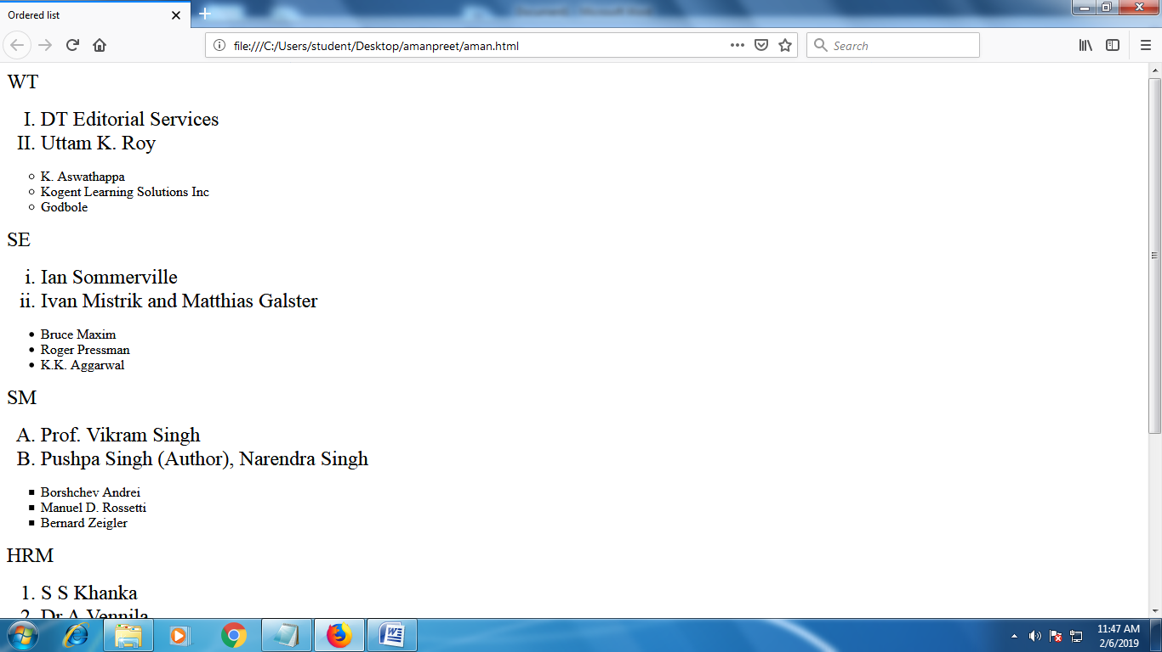

**PRACTICAL-1:LIST IN HTML**

**CODE**

<html>

<head>

<title> Ordered list</title>

</head>

<body>=

<font size="5">WT

<ol type="I" start="1">

<li>DT Editorial Services </li>

<li>Uttam K. Roy</li>

</font>

</ol>

<ul type="circle">

<li> K. Aswathappa</li>

<li>Kogent Learning Solutions Inc</li>

<li>Godbole</li>

</ul>

<font size="5">SE

<ol type="i" start="1">

<li>Ian Sommerville</li>

<li> Ivan Mistrik and Matthias Galster</li>

</font>

</ol>

<ul type="disc">

<li> Bruce Maxim </li>

<li>Roger Pressman</li>

<li> K.K. Aggarwal </li>

</ul>

<font size="5">SM

<ol type="A" start="1">

<li>Prof. Vikram Singh </li>

<li>Pushpa Singh (Author), Narendra Singh </li>

</font>

</ol>

<ul type="square">

<li>Borshchev Andrei</li>

<li>Manuel D. Rossetti</li>

<li>Bernard Zeigler</li>

</ul>

<font size="5">HRM

<ol type="o" start="1">

<li> S S Khanka </li>

<li>Dr.A.Vennila </li>

</font>

</ol>

<ul type="circle">

<li> Dr.A.Mekala</li>

<li> Gary Dessler </li>

<li> K. Aswathappa</li>

</ul>

<font size="5">RDBMS

<ol type="I" start="1">

<li> Pooja Sharma</li>

<li>Kapure Gauri </li>

</font>

</ol>

<ul type="disc">

<li>Anany Levitin</li>

<li> D.S. Sehrawat </li>

<li> Paul DuBois </li>

</ul>

</body>

</html>

**PRACTICAL-2:TABLE IN HTML**

**OUTPUT**

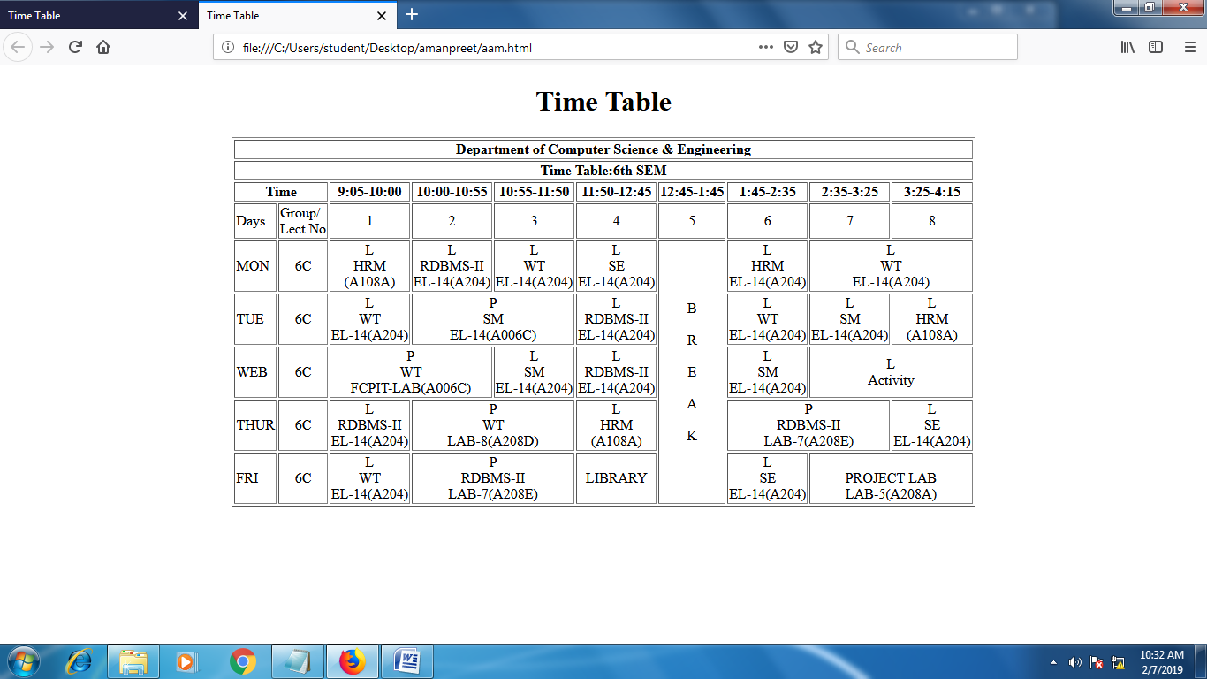

**PRACTICAL-2:TABLE IN HTML**

**CODE**

<html>

<head>

<title>Time Table</title>

</head>

<body>

<center>

<h1>Time Table</h1>

</center>

<center>

<table border="1px">

<tr>

<th colspan="10">Department of Computer Science & Engineering</th>

</tr>

<tr>

<th colspan="10">Time Table:6th SEM</th>

</tr>

<tr>

<th colspan="2">Time</th>

<th>9:05-10:00</th>

<th>10:00-10:55</th>

<th>10:55-11:50</th>

<th>11:50-12:45</th>

<th>12:45-1:45</th>

<th>1:45-2:35</th>

<th>2:35-3:25</th>

<th>3:25-4:15</th>

</tr>

<tr>

<td>Days</td>

<td>Group/<br>Lect No</td>

<td><center>1</center></td>

<td><center>2</center></td>

<td><center>3</center></td>

<td><center>4</center></td>

<td><center>5</center></td>

<td><center>6</center></td>

<td><center>7</center></td>

<td><center>8</center></td>

</tr>

<tr>

<td>MON</td>

<td><center>6C</center></td>

<td><center>L<br>HRM<br>(A108A)</center></td>

<td><center>L<br>RDBMS-II<br>EL-14(A204)</center></td>

<td><center>L<br>WT<br>EL-14(A204)</center></td>

<td><center>L<br>SE<br>EL-14(A204)</center></td>

<td rowspan="5"><center>B<br><br>R<br><br>E<br><br>A<br><br>K</center></td>

<td><center>L<br>HRM<br>EL-14(A204)</center></td>

<td colspan="2"><center>L<br>WT<br>EL-14(A204)</center></td>

</tr>

<tr>

<td>TUE</td>

<td><center>6C</center></td>

<td><center>L<br>WT<br>EL-14(A204)</center></td>

<td colspan="2"><center>P<br>SM<br>EL-14(A006C)</center></td>

<td><center>L<br>RDBMS-II<br>EL-14(A204)</center></td>

<td><center>L<br>WT<br>EL-14(A204)</center></td>

<td><center>L<br>SM<br>EL-14(A204)</center></td>

<td><center>L<br>HRM<br>(A108A)</center></td>

</tr>

<tr>

<td>WEB</td>

<td><center>6C</center></td>

<td colspan="2"><center>P<br>WT<br>FCPIT-LAB(A006C)</center></td>

<td><center>L<br>SM<br>EL-14(A204)</center></td>

<td><center>L<br>RDBMS-II<br>EL-14(A204)</center></td>

<td><center>L<br>SM<br>EL-14(A204)</center></td>

<td colspan="2"><center>L<br>Activity<br></center></td>

</tr>

<tr>

<td>THUR</td>

<td><center>6C</center></td>

<td><center>L<br>RDBMS-II<br>EL-14(A204)</center></td>

<td colspan="2"><center>P<br>WT<br>LAB-8(A208D)</center></td>

<td><center>L<br>HRM<br>(A108A)</center></td>

<td colspan="2"><center>P<br>RDBMS-II<br>LAB-7(A208E)</center></td>

<td><center>L<br>SE<br>EL-14(A204)</center></td>

</tr>

<tr>

<td>FRI</td>

<td><center>6C</center></td>

<td><center>L<br>WT<br>EL-14(A204)</center></td>

<td colspan="2"><center>P<br>RDBMS-II<br>LAB-7(A208E)</center></td>

<td><center>LIBRARY<br></center></td>

<td><center>L<br>SE<br>EL-14(A204)</center></td>

<td colspan="2"><center><br>PROJECT LAB<br>LAB-5(A208A)</center></td>

</tr>

</table>

</center>

</body>

</html>

**PRACTICAL-2:FRAME IN HTML**

**OUTPUT**

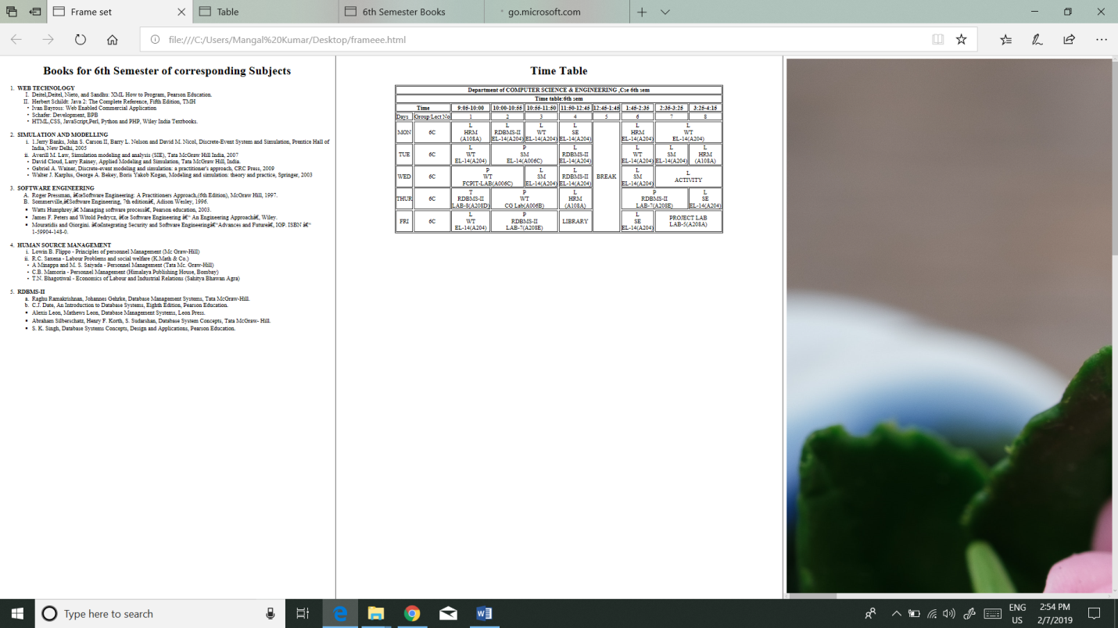

**PRACTICAL-3:FRAME IN HTML**

**CODE**

<html>

<head>

<title> Frame set </title>

</head>

<frameset cols="30%,40%,30%">

<frame name="top" height="500px" src="C:\Users\Mangal Kumar\Desktop\WT\Practical1.html">

<frame name="main" src="C:\Users\Mangal Kumar\Desktop\WT\Time Table.html">

<frame name="bottom" src=" C:\Users\Mangal Kumar\Desktop\3.jpg">

</Frameset>

</html>